**Calendar Event and   
Task List Manager:**

**Usability Test Report**



**Prepared by Team Thundercats**

Shubhangi Rakhonde

David Schechter

Zayd Hammoudeh

**Date of Submission: March 4, 2015**

# Summary

The usability test for Team Thundercats’ Calendar Event and Task List Manager was performed on February 26, 2015. We received beneficial and meaningful feedback from both the tester and the broader class; this feedback motivated specific improvements to our design, which we have detailed in the subsequent sections including both the theoretical foundations for the modifications as well as before and after images.

# Search Box Functionality

For a given webpage, some users are “search dominant” in that they navigate through the site by using a site’s search box while others are link “dominant” in that they browse through the site via links. Any modern website must accommodate both types of users well. One student noted that our original page did not include a search box as shown in figure 1.

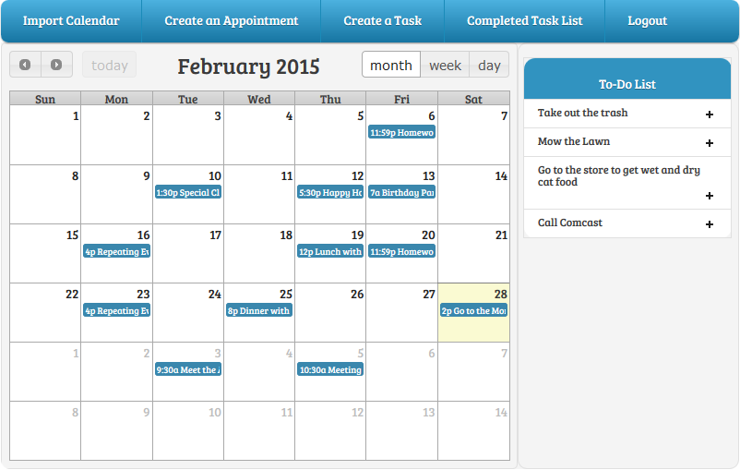

Figure – Original Layout of the Main Page without Search Included

In our very early planning, we decided that a search feature would not be included in our prototype since we did not intend to support it in this demonstrative version. What is more, our planning considered primarily “link dominant” users. This decision was a mistake not only because “search dominant” users may find the site difficult to navigate but also because our site design lends itself, in its own nontraditional way, to the “Feature, Search, and Browse” design pattern. The “Feature” in our design is clearly the calendar since it is the largest item on the page; what is more, if a user has many scheduled events, appointments, and meetings, the calendar will be very information dense as well. In addition, the to-do list provides a type of browseable list. By including, the search box as shown in figure 2, we enable searching without in any way detracting from the site’s overall browseability. Rather, search functionality would enable a user to quickly locate all future events and incomplete to-do items based off specific keywords. For example, a user could search for “Homework” to find all outstanding homework related to-do tasks.

# Calendar Event Color Coding

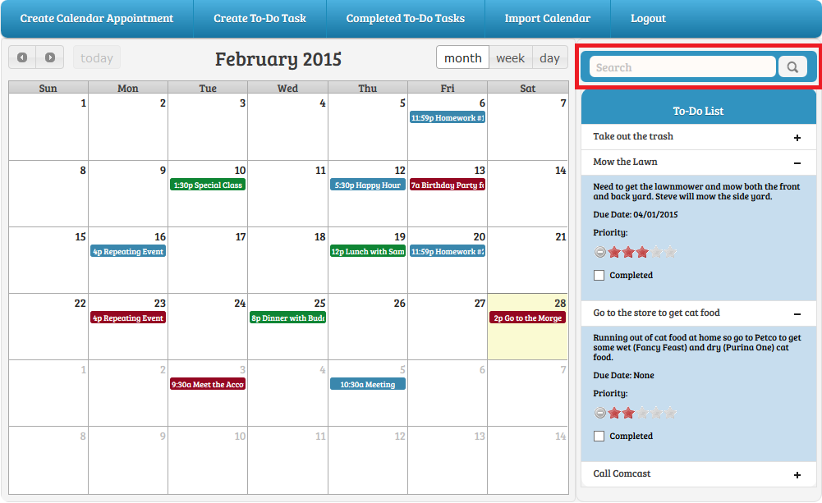

Figure – Modified Layout of the Main Page with Search Included

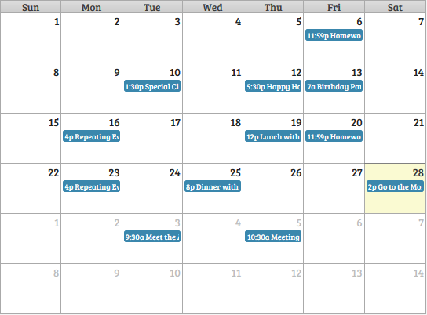

Figure – Original Calendar with Uniform Appointment Coloring

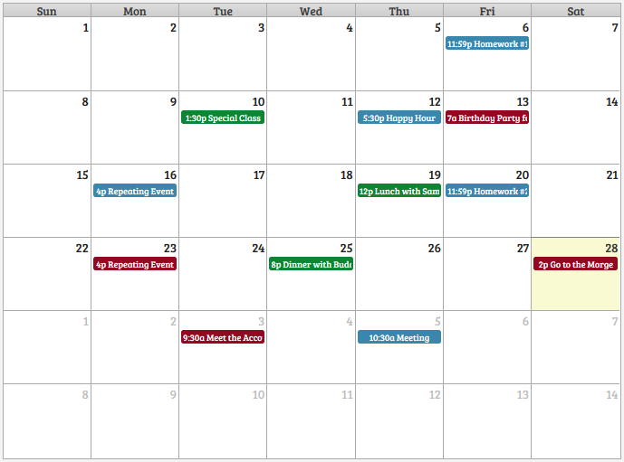

Figure – Modified Calendar with Appointment Color Coding

As described previously, the main “feature” of our website is the central calendar; it is the largest in terms of size and can be the densest in terms of information. When deciding on the color scheme for calendar appointments, our original focus was on ensuring consistency by making all of the calendar events the same color as shown in figure 3.

When a user is examining a webpage, they typically do not “read” the text in the traditional sense. Rather, the user’s behavior is more akin to scanning where they are looking for specific keywords and triggers. One of the points of feedback we received during the usability test was that users should be able to configure the calendar so that appointments can individually have different colors. This recommendation aligns with the Gestalt principle of similarity where a user typically associates things that are visually similar (in this case similar through color).  To that end, an example where color coding of events would be useful is when a user wants to visually differentiate professional and personal appointments by making the two categories of appointments different colors. Our modified calendar with appointment color coding is shown in figure 4.

# Menu Item Naming and Ordering

Concerning the menu bar at the top of the main page, we received two primary pieces of feedback from both the tester as well as the class as whole. First, the tester found the original menu bar button descriptions (shown in figure 5) to be unclear. For instance, from just reading the menu text, she was unsure of the exact function performed by the “Create a Task” button. To better align the application’s functionality with the mental models of users, we renamed some of the menu bar items as shown in figure 6. The specific changes were:

1. “Create an Appointment” was changed to “Create Calendar Appointment” as the tester was unable to quickly distinguish between to-do list tasks and calendar appointments. This new version clearly states that the button is related to the calendar.
2. “Create a Task” was modified to “Create To-Do Task”. This new version more explicitly links the task to the to-do list.
3. “Completed Task List” was changed to “Completed To-Do Tasks” to again more explicitly associate this item with the to-do list.

Original Menu Bar.png

Figure – Original Main Page Menu Bar

Modified Menu Bar.png

Figure – Modified Main Page Menu Bar

A second point of feedback from the class was to improve the information architecture of the page by ordering items in the menu bar according to the likelihood that the user will use that feature. A student specifically mentioned that he would rarely, if ever, import calendars from a third party site so putting that item first in the menu bar may not be ideal. In our original planning, we had not paid sufficient attention to the optimal ordering of the menu bar causing us to overlook this detail. We decided to adopt the student’s feedback and place “Import Calendar” second to last in the list immediately before “Logout.”

# To-Do Item Due Date

Our application combines calendar appointments (which we describe as synchronous events) with to-do items (which we describe as asynchronous tasks that are not associated with a specific time). The intent behind the to-do list was that the user could complete the task at his/her convenience. As such, in the original form to create a to-do task as shown in figure 7, we did not include a feature for the user to specify a “Due” (or to borrow a legal term a “Drop Dead”) date, which would serve as the absolute latest the task could be done.

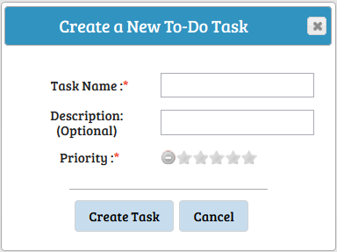

Figure – Original To-Do Task Creation Form

The usability tester mentioned that she would like to have “due dates” for tasks. For example, if a task was to “File Income Tax”, the “due date” would need to be April 15. To accommodate this feature, we added a “Due Date” field to the task creation form as shown in figure 8. This field is optional (as denoted by no red adjacent star) since not all tasks necessarily have a due date.

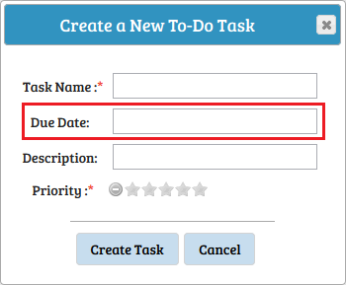

Figure – Modified To-Do Task Creation Form

With the addition of the to-do task “Due Date”, the inlay list used to display all open to-do tasks also needed to be updated to include a field for this information. The updated “Due Date” field in the to-do list is shown in figure 9.

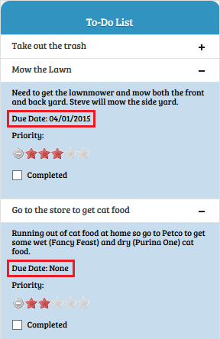

Figure – Modified To-Do List with Added Due Date Field

# Skipping the Setting of a To-Do Item’s Completion Time

In our mental model for the to-do list, we had expected that a user would want to specify a task completion time in the vast majority of cases. As such, when we designed the menu for completing a task, we did not prominently display the feature to bypass specifying a task completion time.

Figure 10 is the site’s original menu for specifying a task’s completion time; for a user to bypass this menu, they would need to click the “X” in the top right corner. Admittedly, this process is not optimally intuitive.

During the usability test, the user showed little interest in specifying a task completion time to the point of being somewhat confused by the process. In her mental model, this feature did not provide much utility, and she quickly wanted to bypass the associated menu. To address her feedback, we added the “Skip” button to the task completion form as shown in figure 11 to more prominently feature the ability to skip the step of specifying a task completion time. With the introduction of this new button, we judged that the “Finish” button’s text should be modified since “Finish” would not make sense when juxtaposed with “Skip”. As such, the “Finish” button’s text was modified to “Set Completion Time”, which we believe more completely describes its functionality.

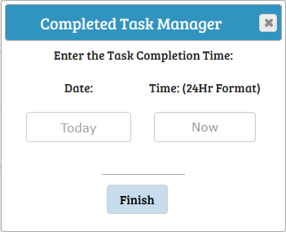

Figure – Original Form for Specifying a To-Do Item’s Completion Time

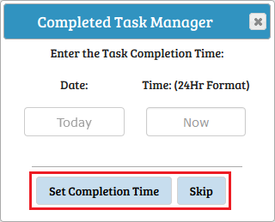

Figure – Modified Form for Specifying a To-Do Item’s Completion Time